17th July 2001
- Sunshine Of The Summer
- Cool
- I Still Got My Dancin’ Shoes
- If We Meet Again
- Sweet Futility *
- How It Ever Came To Be
- Is It Not The Same
- Sorry
- Falling In Love Again
- I Believe

John Fallon
at The Tinderbox Café, London

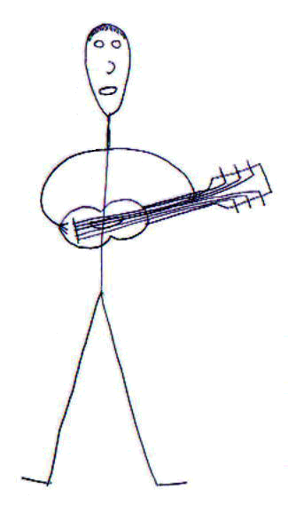
17th July 2001

Email: info@twoonetwomusic.com
Website: www.twoonetwomusic.com
All songs © John Fallon except * © Mike Ferguson.
Mastered at Richmond Studios, Dublin, Ireland.
Recordings owned by The Virtually Acoustic Club, London.

17th July 2001
- Sunshine Of The Summer
- Cool
- I Still Got My Dancin’ Shoes
- If We Meet Again
- Sweet Futility
- How It Ever Came To Be
- Is It Not The Same
- Sorry
- Falling In Love Again
- I Believe

Email: info@twoonetwomusic.com
Website: www.twoonetwomusic.com

